Guide Document to Use ‘ipywidgets’ Dropdown Filter in Folium Mapping

# This document is designed to provide a comprehensive guide on using the ‘ipywidgets’ dropdown filter in Jupyter Notebooks to create interactive maps with Folium. By the end of this guide, you will be able to filter data dynamically on a map using a dropdown menu. This is particularly useful for visualizing geographic data and providing an interactive experience.

### **1. What You Will Learn**

### Setting Up Your Environment

### Loading and Preparing Data

### Creating a Basic Map with Folium

### Adding a Dropdown Filter with ‘ipywidgets’

### Linking the Dropdown to the Map

### Customizing the Map and Dropdown

### Deploying and Sharing Your Map

**2. Setting Up Your Environment**

Before we begin, ensure that you have the required packages installed in your environment. You will need:

* Folium for mapping
* ‘ipywidgets’ for the dropdown filter

You can install these packages using the following commands:

**3. Loading and Preparing Data**

Let's start by loading the data you'll use for mapping. For this guide, we'll use a dataset containing locations of cafes and restaurants.

**Example Dataset Structure**

Assume you have a CSV file with the following columns:

* trading_name: Name of the business (e.g., "Cafe Good")
* latitude: Latitude coordinate (e.g., -37.8136)
* longitude: Longitude coordinate (e.g., 144.9631)
* seating_capacity: Number of seats available at the location

Here’s how you can load the data:

**4. Creating a Basic Map with Folium**

Next, create a basic map using Folium. Folium is a powerful Python library that makes it easy to visualize data that's been manipulated in Python on an interactive Leaflet map.

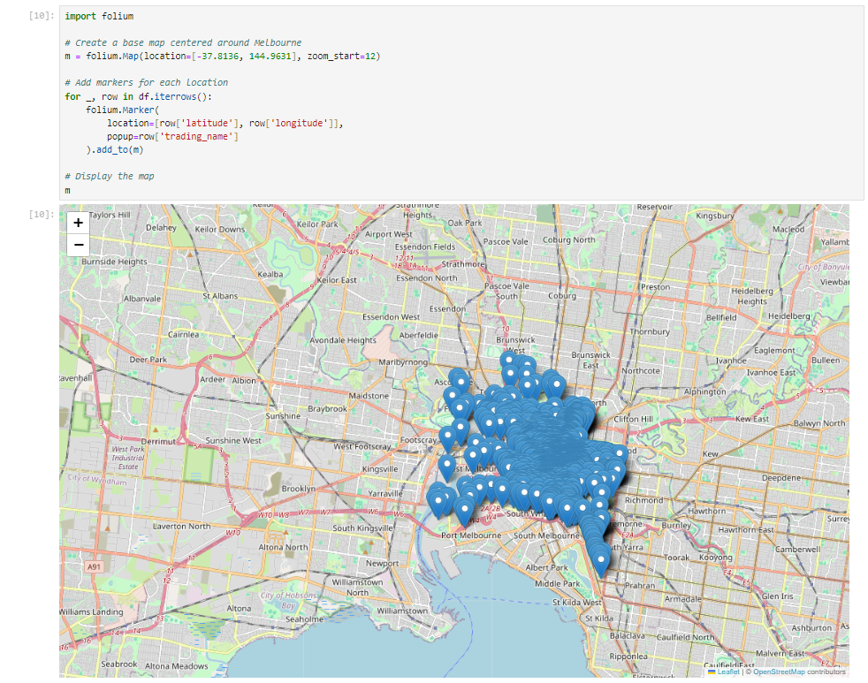

**5. Adding a Dropdown Filter with ‘ipywidgets’**

To make the map interactive, we'll add a dropdown menu using ipywidgets that allows users to filter the displayed locations by business name.

Now, import ‘ipywidgets’ and create a dropdown widget:

**6. Linking the Dropdown to the Map**

Now that we have a dropdown, let's link it to the map so that the map updates when a different option is selected.

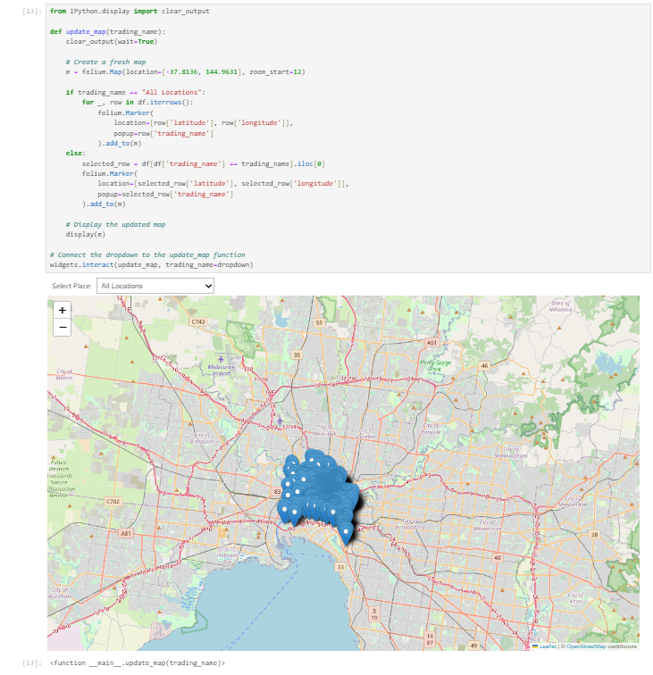

**Explanation:**

* clear_output(wait=True): Clears the previous map when a new selection is made.
* Dropdown Options: If "All Locations" is selected, all markers are displayed. Otherwise, only the selected location is shown.
* Interactive Map: The map updates in real-time based on the user's dropdown selection.

**7. Customizing the Map and Dropdown**

You can further customize the map and dropdown to enhance the user experience:

**Customizing the Dropdown**

You can adjust the appearance of the dropdown by setting the layout:

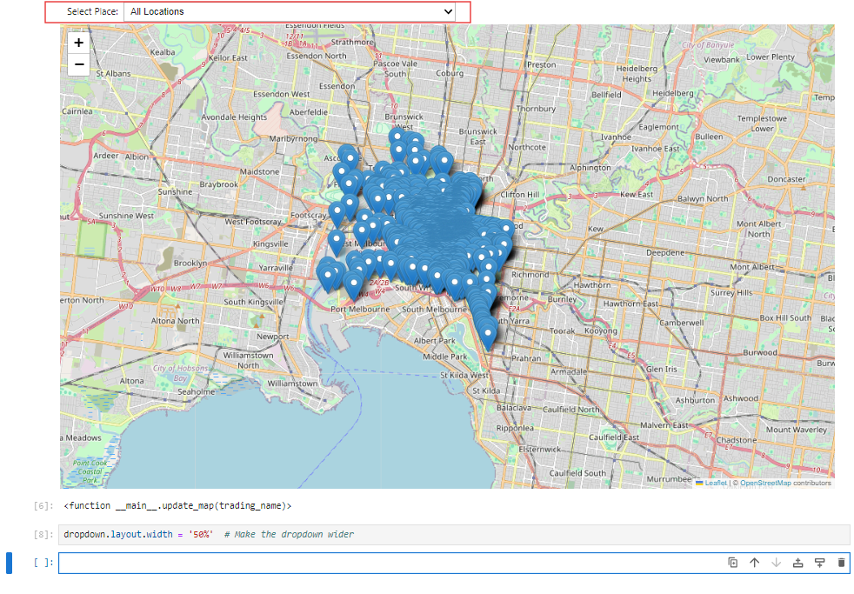

**Customizing Markers**

Markers can be customized with different icons and colours:

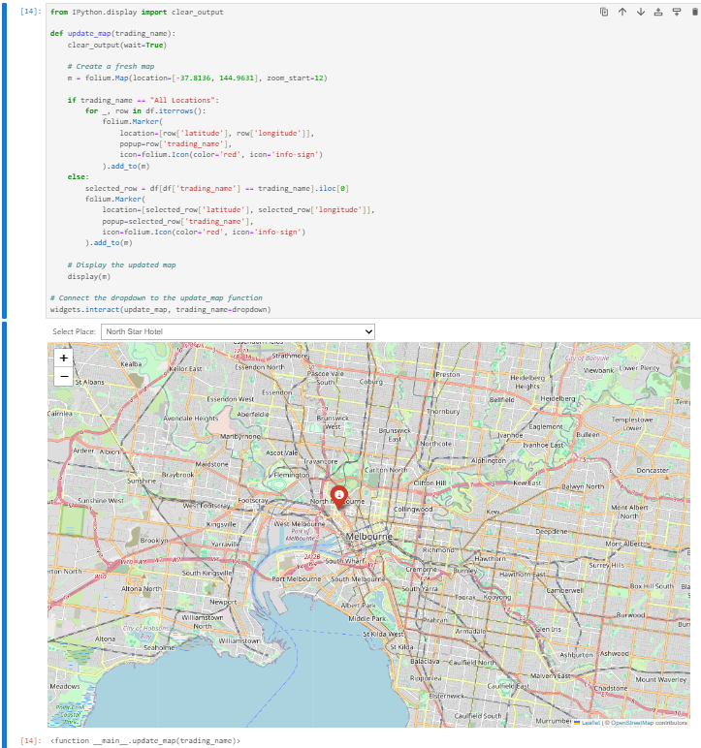

**8. Conclusion**

### This guide has walked you through the process of creating an interactive map using folium and ‘ipywidgets’ in Jupyter Notebook. By integrating a dropdown filter, you can dynamically display and filter specific data points on your map, providing a powerful tool for data visualization and exploration. Whether you are a beginner or looking to enhance your mapping capabilities, these techniques allow you to create engaging and informative geographic visualizations that can be easily customized and shared. Continue experimenting with different datasets and customizations to further expand your skills and make your visualizations even more impactful.

**Author**

Venuka 2024.v1